Victims of domestic violence can break rental agreements early under new Alberta law

Residential Tenancies Amendment Act took effect on Aug. 8

CBC News Posted: Aug 09, 2016 12:22 PM MT Last Updated: Aug 09, 2016 1:07 PM MT
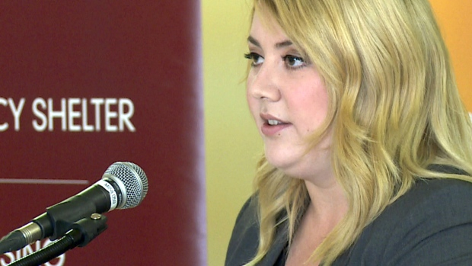
Calgary MLA Deborah Drever introduced a private member's bill last fall to make it easier for victims of domestic violence to get out of rental agreements. (CBC)
A new law spearheaded by Calgary MLA Deborah Drever designed to help victims of domestic violence get away from their abusers came into force Monday.
The Residential Tenancies (Safer Spaces for Victims of Domestic Violence) Amendment Act allows renters to break a lease early, without a financial penalty, by showing their landlord a certificate verifying that they're at risk.
"I brought this bill forward because finances should never be a barrier to fleeing violence," Drever said in a release.
"These changes will make a real difference for survivors of domestic abuse. I am honoured it passed unanimously and that today, it's the law."
To get a certificate, a tenant will need to give the ministry of Human Services an emergency protection order, a peace bond or a letter from a certified professional — such as a doctor, nurse, social worker or psychologist — confirming they or their children are in danger.

Better support
The new law will also help victims get in touch with services for survivors of domestic violence, the province says.
Several organizations — including the YWCA, HomeFront Calgary and the Alberta Council of Women`s Shelters — applauded the government for enacting the new law.
"Women tell us that economic insecurity and stress of finding a new home are among the top reasons they stay in unsafe, abusive relationships," said YWCA CEO Sue Tomney in a release.
"This amendment … addresses these stressors and enables women to escape abusive relationships with the supports they need."

